**Week-5 Microservices with SpringBoot3 and SpringCloud**

1. **Creating Microservices for account and loan:**

**In this hands on exercises, we will create two microservices for a bank. One microservice for handing accounts and one for handling loans. Each microservice will be a specific independent Spring RESTful Webservice maven project having it's own pom.xml. The only difference is that, instead of having both account and loan as a single application, it is split into two different applications. These webservices will be a simple service without any backend connectivity.**

**Code:**

**Project: account**

**AccountController.java**

package com.cognizant.account.controller;

import org.springframework.web.bind.annotation.*;

import java.util.Map;

import java.util.HashMap;

@RestController

@RequestMapping("/accounts")

public class AccountController {

@GetMapping("/{number}")

public Map<String, Object> getAccount(@PathVariable String number) {

Map<String, Object> account = new HashMap<>();

account.put("number", number);

account.put("type", "savings");

account.put("balance", 234343);

return account;

}

}

**AccountApplication.java**

package com.cognizant.account;

import org.springframework.boot.SpringApplication;

import org.springframework.boot.autoconfigure.SpringBootApplication;

@SpringBootApplication

public class AccountApplication {

public static void main(String[] args) {

SpringApplication.run(AccountApplication.class, args);

}

}

**Application.properties**

spring.application.name=account

server.port=8081

**Project: loan**

**LoanController.java**

package com.cognizant.loan.controller;

import org.springframework.web.bind.annotation.*;

import java.util.Map;

import java.util.HashMap;

@RestController

@RequestMapping("/loans")

public class LoanController {

@GetMapping("/{number}")

public Map<String, Object> getLoan(@PathVariable String number) {

Map<String, Object> response = new HashMap<>();

response.put("number", number);

response.put("type", "car");

response.put("loan", 400000);

response.put("emi", 3258);

response.put("tenure", 18);

return response;

}

}

**LoanApplication.java**

package com.cognizant.loan;

import org.springframework.boot.SpringApplication;

import org.springframework.boot.autoconfigure.SpringBootApplication;

@SpringBootApplication

public class LoanApplication {

public static void main(String[] args) {

SpringApplication.run(LoanApplication.class, args);

}

}

**Application.properties**

spring.application.name=loan

server.port=8082

**Output:**

**Project: account**

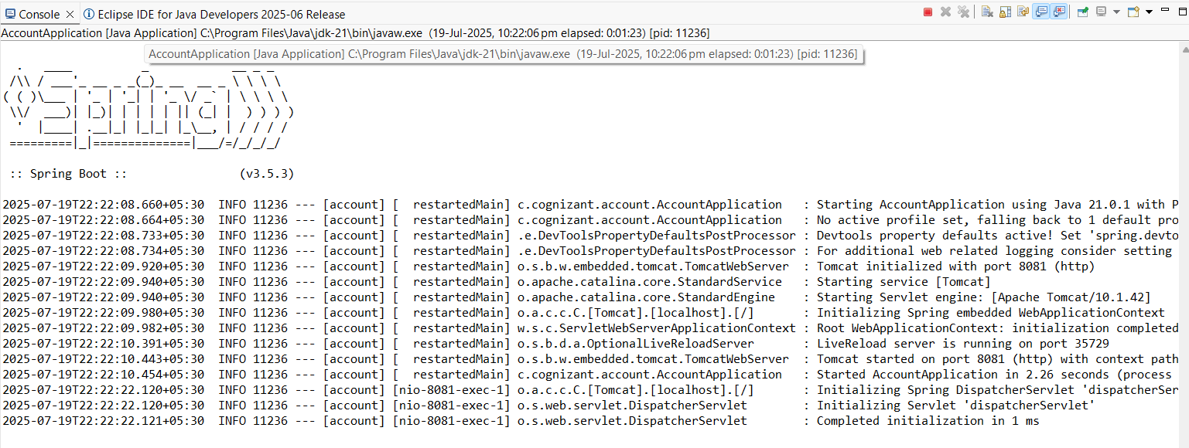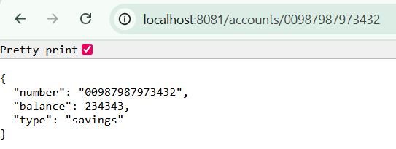

**Project: loan**

